TCGA Project

# Abstract

In this paper an attempt was made to differentiate cancer data using RNA-Seq data from TCGNA. The results showed a good separation between namely ovary, skin and testis cancer types, but it proved difficult to separate colon and rectum data. An attempt to separate the two cancer types using machine learning methods proved difficult with an FPR of x%. Feature selection was then used as an attempt to differentiate between the two.

# Introduction

The cancer genome project is …

Wanting to differentiate between rectum, colon, skin and testis/ovarian cancer

Whether it is rectum or colon cancer plays a big difference treatment wise (<https://healthblog.uofmhealth.org/cancer-care/how-colon-and-rectal-cancer-differ>)

As per the ***Law of Parsimony*** of ‘*Occam’s Razor’*, the best explanation to a problem is that which involves the fewest possible assumptions. Thus, feature selection becomes an indispensable part of building machine learning models. From <https://www.analyticsvidhya.com/blog/2020/10/feature-selection-techniques-in-machine-learning/>

# Methods

<https://www.nature.com/articles/s41597-019-0207-2>

Data was extracted from TCGA using code in Appendix 1. The data contained RNA-Seq data from Skin, Ovary, Testis, Colon and Rectum cancer patients. The criteria for the datasets was that the sample had to have at least 20 million reads and genes had to have over 1024 mapped reads in at least 10 samples. From each cancer project, 100 samples was randomly selected.

Principal component analysis (PCA) was performed using prcomp in the stats package. The two principal components was then visualized using the built in plot from base.

Differential expression (DE) analysis was performed using LmFit and eBayes functions from the limma package (version 3.12). All genes were

First, we used PCA to get an initial overview of the data.

Then used a feature selection or DEG analysis to reduce dimensionality of the data.

After that we used two different machine learning methods, namely KNN and SVM with and without cross validation to compare. Afterwards we initialized a differential co-expression network for each condition and used hierarchical clustering to find altered clusters in the different conditions differentia matrix. We only compared testis vs ovary and rectum vs colon.

Supervised learning:

(a) PCA/hierarchal clustering/heatmap to get an initial overview of the data,

(b) differential expression analysis to reduce the dimensionality,

(c) machine learning to predict outcome,

(d) extract some biological insight from the machine learning model

Implement at least two different machine learning methods and use feature selection (differential expression) and cross validation to evaluate them. Søk etter

# Results

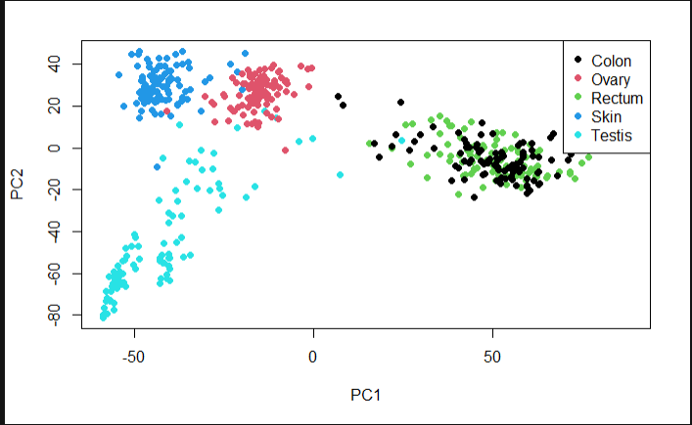

Figure 1 PCA of cancer data. Principal components only account for x% of the deviation

The PCA plot in figure 1 shows a good separation on Ovarian, testicular and skin cancer data, but struggles to separate rectum and colon as expected.

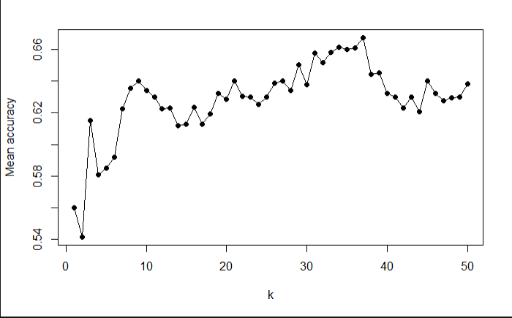

Figure 2 KNN testing with cross validation for most efficient KMER in separating colon and rectum data. Shows highest accuracy at 37. kmers.

Keep in mind that the dataset only has 200 possible k’s so the boundary between the classes using linear method is not distinct at all.

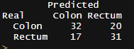

Figure 3 KNN table without cross validation for colon and rectum data after differential expression

After running KNN without cross validation the initial observation from PCA plot is again observed. It appears to be difficult to separate rectum and colon data, whereas the other data is easier to separate. Without cross validation the accuracy was calculated to be 0.63, whereas with it was at 0.67. Which indicates that a linear model is not fitted for this dataset.

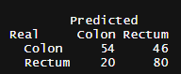

Figure 4 KNN table with cross validation showing predicted vs real

Continuing with rectum vs colon cancer in comparisment, after cross validation the accuracy has decreased somewhat (, but it is still difficult to separate rectum and colon.



Figure 5 SVM without cross validation with a sigmoid kernel.

SVM without cross validation shows and accuracy of 0.988 After running a cross validation with 10 indices the error rate was calculated to be 0.838 (see appendix x).

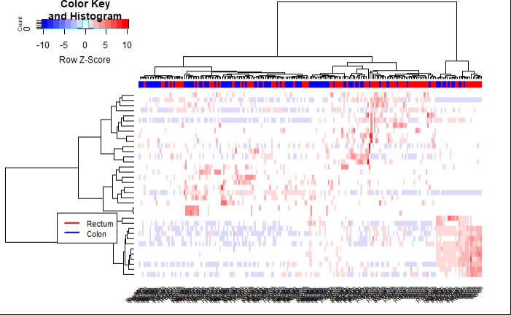

Figure 6 Heatmap with correlation for colon and rectum comparisement. Shows a high occurence of no correlation, meaning few co-expression of genes.

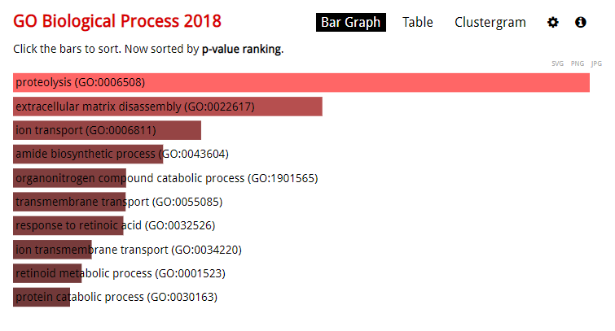

After retrieving significant genes that separate colon and rectum data it appears the biggest difference lies in proteolysis

# Discussion

The two machine learning methods has a similar accuracy at around 0.82.

The rectum is a part of the colon and it might be possible that rectum-cancer has been labelled as colon-cancer in this dataset. However seeing as they are so closely knit together in the PCA analysis there might also be anatomical reasons for this. According to the GO-analysis after sorting for significant genes using DESeq analysis, there are only 36 genes of significance. That is less that 0,08% of the total genes represented in this dataset. The GO analysis shows that the significant genes are prominent in proteolysis which is the first step in the utilization of protein in the human colon, and is in other words not so surprising. However, an article made by (ubiquinetous

# References